Yellowhouse Lodge #841
A.F. & A.M.
5015 Gary Ave, Lubbock, Texas 79413
806-765-6041
www.yellowhouse841.org yellowhousemasons@gmail.com
December 2021 – Monthly Newsletter

2021-2022 OFFICERS
Steve Sperry Worshipful Master

Louis Rapp Senior Warden

Jeremy Jones Junior
Warden

David Mead Treasurer Dwayne McInroe Secretary Joey Powers Chaplain
Jeff Goolsby Senior Deacon

Jeremy Campanella Junior
Deacon

Lynne Haire Senior Steward

Dustin Delano Junior
Steward

Mike Delano Marshal

Bob Chesser Master of Ceremonies

Nathan Shrode Tiler

Garland Timms Trustee Charles Mire Trustee
Terry Ewings Trustee

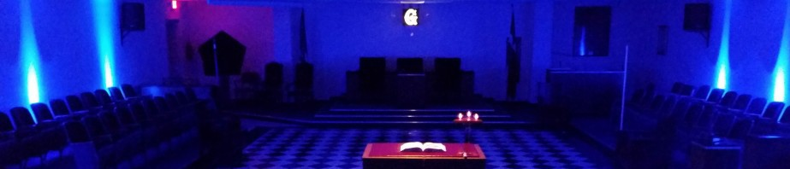
From the East . . .
Greetings Brethren,

Merry Christmas and happy holidays brethren! What a great time to be a mason! Being charitable and continuing to be the upright citizen and brother is what we do best! Take time to thank the Grand Architect of the Universe for all that he has provided and done for us. Thank him for masonry too! This fantastic fraternity has survived through good times and bad and we are still here! This fraternity in my opinion is a God thing!

I have reached out to the instructors to keep the candidates on track. I will be contacting the candidates as well to encourage their journey to be an efficient and exciting one!

In case you were not at the last stated meeting, we have an update on the family we are helping with their Christmas. The mother passed away so things will be very tough for this family. I want our lodge to STEP UP and help this family out by bringing gifts to these children. The family will be at the lodge on Tuesday December 7th at 6:30pm. Please bring the wrapped gifts to the lodge no later than 6pm that day.

We will have a short program this next meeting that you will find interesting and proud of our lodge. I have been in close contact with brother Jeremy Hogan Past master of Abernathy lodge who has been going through our old minutes and has given me a few high lights of his notes. I will share these nuggets at our next stated meeting. Please keep our brethren and families that are ill in your prayers and pray for our lodge as well. I believe we are doing great things and want to keep the momentum going!

There will be some fun activities for the wives and children at the next stated meeting so please come out and enjoy fellowship and keep our fraternity alive
#1 (13yrs old): Sizes: Shirt-XL, Pants-14, Shoes-7. Likes: Jewelry, perfume, nail polish, pop it & simpl dimpl toys, pajamas, anything to do with llamas, laptop, or iPad
Daughter #2 (12yrs old): SIzes: Shirt-M, Pants-14-16 youth/misses, Shoes-6. Likes: Jewelry, headbands, pop it & simpl dimpl toys, pajamas, anything to do with sloths, laptop, or iPad. Father: Sizes: Shirt-L, Pants- 32x32, Shoes-9.5
Likes: Collects Eagles and likes photography

Fraternally,

Steve Sperry Worshipful Master

Floor Practice every Tuesday except the 2nd Tuesday @ 6:30pm!

From the West . . .
BRETHREN:

I was thinking about all I have to be thankful for this year and with Thanksgiving just around the corner I thought it appropriate to write this newsletter regarding the same. I’m very thankful to have a wonderful wife of thirty-four years who supports me in my every endeavor. She never questions my duties at the Lodge or the work I do at home and very often jumps in to help at the lodge when I’m working there. I’m thankful for the Lodge for acceptance and for the confidence the brothers have in me when I’m voted into the next office in line. I’m thankful for the many friends I have made at the Lodge and for every experience I have been through and being a part of. I’m thankful I made it through the war and for coming home with all my extremities intact except my mind and I was probably addled when I enlisted. The demons still come but there is always a brother who is willing to listen.
I also thought of my failures in helping others and the Lodge as my obligations remind me to do. There are times when I have failed to do more to help the brothers and the Lodge as a whole and for those times, I’m also thankful as it’s a constant reminder to try and do more, not for recognition but for my own happiness and peace of mind. If this month is a time to give thanks to God for all the miracles he performs each day, then December is a time for giving. We give when we volunteer to teach a new Brother or when we do little jobs around the Lodge. It is that spirit of giving we should nourish and encourage not only of ourselves but of our fellow Brothers. Assist, or offer to do so, the stewards with cleanup after the meal. If we see a full wastebasket then empty it and put a new bag in. Offer to do the floors in the Lodge for a few hours a week, pick up and cleanup around our beautiful building.
It is through the things we do when no one is watching that we will be judged, the menial task we perform is what the Grand Architect of the Universe looks for when it is our time to stand in front of him.

Fraternally,
Louis Rapp
Senior Warden
SSGT 1ST MARINE DIVISION VIETNAM 1969-1970

BRETHREN:

From the South . . .

Christmas is upon us, gentlemen. It is a time of year to celebrate. We celebrate our family, our friends, sometimes coworkers, and most importantly, our savior.
Christmas is also a time for presents. We give presents and we receive presents. I would like you to think of another kind of present this month and that is being present. Wherever you are or whatever you are doing this next month, be present. Turn off the TV and sit for a talk with your wife, girlfriend, kids, or parents. Put your phone away and ignore those dings, rings, and games for a while. Use that time to be present for those close to you. Give the gift of your time and your undivided attention. Reach out to a friend or family member that you haven’t seen in a while and be present for them. Your presence with those who care about you is massively important. Make sure that you aren’t just physically present but mentally as well.
When in lodge, be present as well. I’m guilty myself of getting lost in my own thoughts during lodge and missing a cue. Pay attention during the lodge meetings and let’s help the lodge be better. Maybe even reach out to a brother that we haven’t seen in lodge for a while and see if you can get him to also be present with us again.
My wish is that all of my brethren will have a blessed and beautiful Christmas season. I hope that you will all enjoy your families and Christmas parties and be mindful of your presence. Just be present.

Junior Warden Jeremy D. Jones

Steward’s Corner:
Something Yummy and Tasty with Dessert, Tea & Water
Sickness and Distress:

