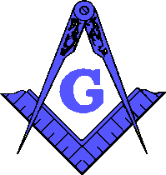 | Yellowhouse Lodge #841  A.F. & A.M.  5015 Gary Ave, Lubbock, Texas 79413  806-765-6041  www.yellowhouse841.org yellowhousemasons@gmail.com | 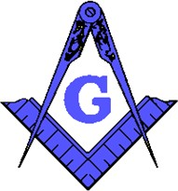
October 2021 – Monthly Newsletter

2021-2022 OFFICERS
Steve Sperry Worshipful Master

Louis Rapp Senior Warden

Jeremy Jones Junior
Warden

David Mead Treasurer Dwayne McInroe Secretary Joey Powers Chaplain
Jeff Goolsby Senior Deacon

Jeremy Campanella Junior
Deacon

Lynne Haire Senior Steward

Dustin Delano Junior
Steward

Mike Delano Marshal

Bob Chesser Master of Ceremonies

Nathan Shrode Tiler

Garland Timms Trustee Charles Mire Trustee
Terry Ewings Trustee

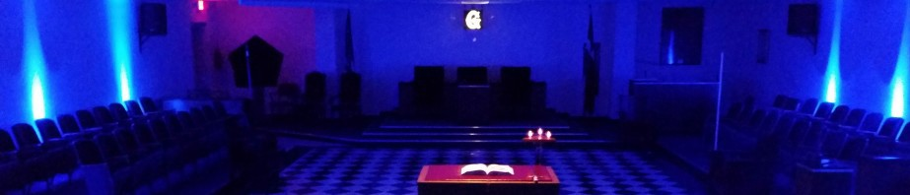
From the East . . .
Greetings Brethren,
October is upon us! This year is going by fast! I’d like to thank the brothers that have stepped up and helped out in meetings and degrees! Very proud of our continued success! Our candidates are moving along very smoothly, and instructors have been phenomenal! The teamwork in the lodge is key to our success! Being on the District service team and traveling to other lodges with our
DDGM has opened my eyes even more about how well Yellowhouse is doing. I hear brothers from other lodges saying very encouraging things about our success! I would really like to emphasize how stepping up and participating in the lodge has helped and continue to help keep our lodge a top-notch lodge! Thank you everyone!

Fraternally, Steve Sperry
Worshipful Master

Floor Practice every Tuesday except the 2nd Tuesday @ 6:30pm!

From the West . . .
BRETHREN:

The blindfold:

Physical blindness in Masonry, as in the language of scriptures, is symbolic of the deprivation of moral and intellectual light. It is equivalent to the darkness of the ancient mysteries in which the Neophytes were enshrouded for period varying from a few hours to many days. The Masonic candidate, therefore, represents one immersed in intellectual darkness, groping in search for that divine light and truth which are the objects of a Masons labor. Darkness has, in all the systems of initiation, been deemed a symbol of ignorance, and so opposed to light, which is the symbol of knowledge, hence, the rule that the eye should not see until the heart had conceived the true nature of those beauties which constitute the mysteries of the Order. In ancient mysteries the aspirant was always shrouded in darkness as a preparatory step to the reception of the full light of knowledge. The time of this confinement in darkness and solitude varied in the different mysteries.

Freemasonry has restored darkness to its proper place, as a state of preparation. It is the symbol of that ante-mundane chaos, from which light issued by Divine command; of the state of nonentity before birth, and of ignorance before the reception of knowledge.

Hence, in the ancient mysteries, the release of the aspirant from solitude and darkness was called the act of regeneration, and he was said to be born again, or to be raised from the dead.

And, in Masonry, the darkness, which envelopes the mind of the uninitiated, is removed by the effulgence of Masonic light. Masons are appropriately called the “Sons of light.”

Fraternally,

Louis Rapp Senior Warden

BRETHREN:

From the South . . .

Fall is upon us. Fall has always been my least favorite season. Everything is dying and turning from the green of summer to brown. It has always meant the end of the fun of warm weather and the coming of cold. It’s just never been my favorite time of year.

This year, someone close told to look at it with a new perspective. It isn’t merely a dying but a chance for things to be reborn. Trees go dormant and rest. Crops produce their harvest. The solstice comes and turns the season. It is an opportunity for dying so that things may be reborn.

This reminds me of our raising. We symbolically die, we are then raised, and taught new things. We are reborn, in a way, but as Master Masons. With that comes a new set of obligations, a new outlook, and a new way we should conduct ourselves. May this season remind us all of what we mean to each other. May this season remind us that we are all on the level and we should conduct ourselves as such. May we all be reminded of that brotherly love and affection that is necessary for men such as us. No matter our mood, outside influences, or whatever else may have brought us to a certain point, let us conduct ourselves in a just and upright manner towards one another.

Junior Warden Jeremy D. Jones

Sickness and Distress: Jeremy Webb – Father Passed

Steward’s Corner:
Something Yummy and Tasty with Dessert, Tea & Water

