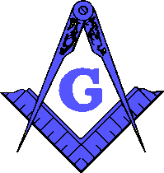 | Yellowhouse Lodge #841  A.F. & A.M.  5015 Gary Ave, Lubbock, Texas 79413  806-765-6041  www.yellowhouse841.org yellowhousemasons@gmail.com | 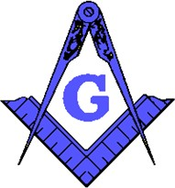
February 2022 – Monthly Newsletter

2021-2022 OFFICERS
Steve Sperry Worshipful Master

Louis Rapp Senior Warden

Jeremy Jones Junior
Warden

David Mead Treasurer Dwayne McInroe Secretary Joey Powers Chaplain
Jeff Goolsby Senior Deacon

Jeremy Campanella Junior
Deacon

Lynne Haire Senior Steward

Dustin Delano Junior
Steward

Mike Delano Marshal

Bob Chesser Master of Ceremonies

Nathan Shrode Tiler

Garland Timms Trustee Charles Mire Trustee
Terry Ewings Trustee

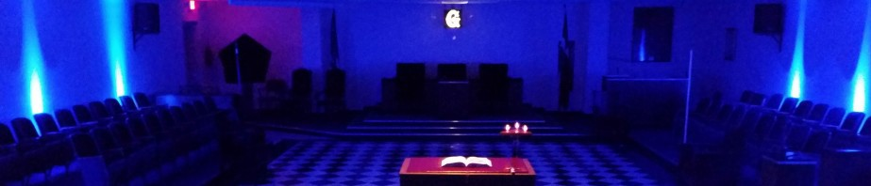
From the East . . .
Greetings Brethren,

Happy February Brethren! I am honored to have our district represented by the new District Deputy Grand Master Right Worshipful Nathan Shrode! I wish him a fantastic year! I encourage everyone to attend for his official visit and give him his home lodge support!
Grand lodge was great and went very well. If you have not been I highly recommend going! Lots of incredible things to see!
It was great to see the area masons at the fantastic teeth event! This area really came together and made the assembly of the kits a breeze! Thank everyone that came out!
Have some very sad news. Brother Allen Ellis’s wife passed away Tuesday evening about 9pm. He needs all the support and prayers so please hold this brother up. I learned about this just minutes ago, so I included this news in the February newsletter.
May brotherly love prevail, and every moral and social virtue cement us.

Fraternally,

Steve Sperry Worshipful Master

Floor Practice every Tuesday @ 6:30pm, except the 2nd Tuesday

From the West . . .
BRETHREN:

I have been asked by those whom I know, what good is Masonry?

We should all be able to answer this question and enlighten those in darkness.
Masonry begets a confidence between individuals that neither party nor sect can accomplish; this is a benefit that extends into every ramification of social life.

It confers authority upon its members to speak confidently yet prudently to an erring Brother. It will never be known in this world how many dear brethren have been saved from temporal and spiritual ruin by whispered counsel, sympathetic warning, and proffered aid. The written and unwritten annals of the Order are full of illustrations of this fact.

Masonry possesses a universal language, understood in all countries, by all nationalities, of many tongues, and of all monotheistic creeds. That language is understood as well in the night session, as by day. The deaf, dumb, and blind can use it as Masons can communicate with one another as long as they possess the sense of hearing, seeing, feeling, or speaking; so that it is strictly true, that Masons can communicate without seeing one another, or speaking a word; either in the daytime or night season, though of course one of these faculties must necessarily be used. There is nothing like this wonderful language for university, so that amid all the vicissitudes of human life, the Mason feels that only one word of Masonic language is sufficient to call to his aid the good offices of brethren near and dear to his heart.

It gives men, irrespective of paltry considerations, a code of life principles, intensifying the noble aspirations. It makes them cosmopolitan, breaking down the petty barriers of country, state, county, town, sect, set, profession, business, family, and wealth. The highest of titles is Brother-no other can take its place. The talents of hod-carrier may place him in the chair. A Grand Master of Ireland, many years ago, the Duke of Leicester, boasted of having risen through every grade, from that of Junior Deacon to the throne of Grand Master. The late President Roosevelt often sat in his lodge, over which his gardener presided as Master.

It unites men in a common work for a common good, as broad, and catholic as mankind. It teaches men that sects, parties and side issues never could influence beyond the bounds of petty associations. It sternly refuses to proselytize, as it wants no material untried. If mankind be worthy of such a beneficent institution, it can wait. It has taken centuries for mankind to arrive at its present state of imperfect moral life; perhaps the time may come when the whole earth shall have become one great Lodge, the ideal of Masonry. Then there will be one government, one faith, one nation, all brethren, because all the children of the Holy, Blessed and Glorious Supreme Architect if the Universe.

Fraternally,
Louis Rapp
Senior Warden
SSGT 1ST MARINE DIVISION VIETNAM 1969-1970

BRETHREN:

From the South . . .

The Masons who were selected to build the temple of Solomon were declared free. These Free Masons were allowed to gather with their families and were exempt from paying taxes. They also had the privilege to bear arms. Thus, they were accepted as free men.

At the destruction of the Temple by Nebuchadnezzar, these Free Masons were taken to Babylon and put into captivity with the Jews. Cyrus, after taking control of Babylon, gave these Masons permission to return to Jerusalem to erect a second Temple, freeing them to do so.

To be free they had to be accepted as free, hence the term Free and Accepted. Not all men in all cases are accepted as free, they are held by the restraints of doctrine and power. To be free in mind and body one must work at it

Junior Warden Jeremy D. Jones

Sickness and Distress:
Allen Ellis’s wife, Marcia, passed away in January
Randale Thompson’s mother passed away

Steward’s Corner:
Something Yummy and Tasty with Dessert, Tea & Water

