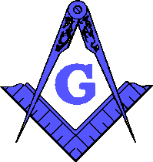 | Yellowhouse Lodge #841  A.F. & A.M.  5015 Gary Ave, Lubbock, Texas 79413  806-765-6041  www.yellowhouse841.org yellowhousemasons@gmail.com | 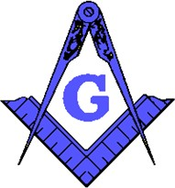
June 2022 – Monthly Newsletter

2021-2022 OFFICERS
Steve Sperry Worshipful Master

Louis Rapp Senior Warden

Jeremy Jones Junior
Warden

David Mead Treasurer Dwayne McInroe Secretary Joey Powers Chaplain
Jeff Goolsby Senior Deacon

Jeremy Campanella Junior
Deacon

Lynne Haire Senior Steward

Dustin Delano Junior
Steward

Mike Delano Marshal

Bob Chesser Master of Ceremonies

Nathan Shrode Tiler

Garland Timms Trustee Charles Mire Trustee
Terry Ewings Trustee

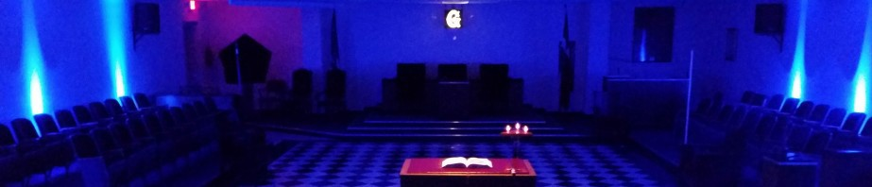
From the East . . .
Greetings Brethren,

Brethren, I want to thank everyone at Yellowhouse lodge for the continued support. I appreciate it deeply. Many brothers have been helping with degree work, instructing and workdays. Be proud of Yellowhouse, we are ensuring we will be around for many more years to come.

We had a discussion to raise the dues to $125. The committee to review this worked hard, crunching the numbers and did a wonderful job. Thank you, dues committee, for stepping up and taking on this responsibility

The candidates are coming along nicely and appreciate the degree team and the brothers that have been teaching the work. I really need more brothers to step up and learn more degree parts. Our floor practice is every Tues, except the 2nd Tues, so please come out and lean a part. Being in a degree will help you understand even more of your masonic journey.

Pray for rain and pray for the continued success at Yellowhouse lodge
Hope to see you at the next stated meeting
Fraternally,
Steve Sperry Worshipful Master
Floor Practice every Tuesday @ 6:30pm, except the 2nd Tuesday

From the West . . .
BRETHREN:

Before the business of the Lodge begins, we stop and say the Pledge of Allegiance to our nations flag. In this time of division in our country, sometimes it seems we do it in a rush instead of with the solemnity it deserves. For this month’s newsletter I would like to quote the late Brother Red Skelton, a 33-degree Brother who was also active in the York Rite and the Shrine, with his commentary on the Pledge.

I - Me, an individual, a committee of one

Pledge - Dedicate all my worldly goods to give without self-pity

Allegiance - My love and devotion

To the Flag - Our standard; Old Glory; a symbol of Freedom; wherever she waves there is respect, because your loyalty has given her a dignity that shouts, Freedom is everybody’s job.

Of the united - That means we have all come together.

States - Individual communities that have United into forty-eight (fifty) great states. Forty-eight (fifty) individual communities with pride and dignity and purpose. All divided with imaginary boundaries, yet united with a common purpose, and that is love for country.

And to the Republic - A state in which sovereign power is invested in representatives chosen by the people to govern. And government is the people; and it’s from the people to the leaders, not from the leaders to the people.

For which it stands

One Nation - One nation-meaning so blessed by God.

Under God

Indivisible - Incapable of being divided

With Liberty - Which is freedom; the right of power to live one’s own life, without threats, fear, or some sort of retaliation.

And Justice - The principal, or quality, of dealing fairly with others

For All - For all- which means, every citizen, be it child or adult

Let us take the time to remember the millions of Americans who have died on the field of battle, willfully giving their lives for our flag and freedom.

Fraternally,
Louis Rapp
Senior Warden
SSGT 1ST MARINE DIVISION VIETNAM 1969-1970

From the South . . .

BRETHREN:
Behavior
Masonic behavior is a subject, if taken into the Lodge for debate, could take up a lot of time. Behavior changes with attitude and the ever-shifting social structure.
In the old charges behavior was divided into six sections:
1. Behavior in Lodge.
2. Behavior after Lodge with members who did not attend.
3. Behavior when brethren meet outside the Lodge.
4. Behavior in the presence of non-members.
5. Behavior at home and in your neighborhood.
6. Behavior toward a strange brother.
Behavior is generally affected by two means:
1. By those around you.
2. By age.
Normally, we are respectful of the people around us, more now than when we were younger. We also have much more tolerance, mainly because of those who tolerated and respected us.
Our behavior reflects who we are and as a Mason this image either improves or taints our institution. To be a considerate member of the Lodge and our brethren is easy. To be a person of integrity to strange brothers, non-members, and even those who would seek to discredit the fraternity, is the most important act of brotherly love one could do for his Lodge and its members.
A Lodge is only as good as its worse member, therefore strive to be a better person.
Junior Warden,
Jeremey Jones
FROM THE SECRETARYAND TREASURER…

Secretary:

Treasurer:
The Masonic Cup fundraiser is completed, and I will be handing out the cups this month and collecting the remaining amounts due. After that I will have a total of our fundraiser and the amount we made for the general fund.
The raffle tickets are printed and being given out by Brother Joey Powers. Make sure everyone collects their packets.

Sickness and Distress:

Steward’s Corner:
Something Yummy and Tasty with Dessert, Tea & Water

